# C# Web Development Basics

# Regular Exam – CHUSHKA

**CHUSHKA** (**C**entral **H**ierarchically-**U**niversal **S**ales **H**ost **K**ickstarter **A**pplication) is a universal web application for selling products, like a web shop. You have been tasked to implement this application by the **Codex Input / Output** organization. There are several requirements you must follow in the implementation.

## Technological Requirements

* Use the Web Server
* Use the MVC Framework
* Use Entity Framework

The Technological Requirements are **ABSOLUTE**. If you **do not follow** them, you will **NOT** be scored for other Requirements.

Now that you know the Technological Requirements, let us see what are the Functional Requirements.

## Database Requirements

The **Database** of the **CHUSHKA** application needs to support **3 entities**:

### User

* Has an Id – (of course) an **integer**
* Has an Username
* Has a Password
* Has a Full Name
* Has an Email
* Has an Role – can be one of the following values (“User”, “Admin”)

### Product

* Has a Name
* Has a Price – think of the right data type here
* Has a Description
* Has a Type – can be one of the following values (“Food”, “Domestic”, “Health”, “Cosmetic”, “Other”)

### Order

* Has an Id – a **String (GUID)**
* Has a Product – a Product
* Has a Client – an User
* Has an Ordered On – a DateTime

Implement the entities with the **correct datatypes**.

## Template Requirements

### Guest Templates

These are the **templates** and **functionalities**, accessible by Guests (**logged out** users).

#### Index Template (route = “/”) (logged out user)

#### Login Template (route = “/users/login”) (logged out user)

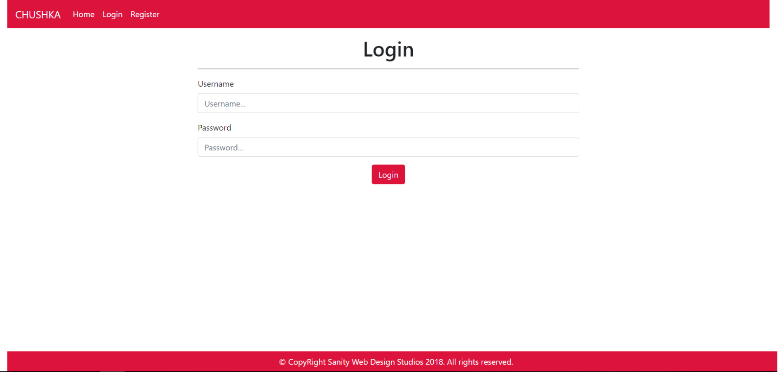

#### Register Template (route = “/users/register”) (logged out user)

### User Templates

These are the **templates** and **functionalities**, accessible by Users (**logged in** users with Role - User).

#### LoggedIn Index Template (route=”/”) (logged in user)

**NOTE**: Products on this page have their description substringed to the 50th symbol, and then accompanied by 3 dots “…”

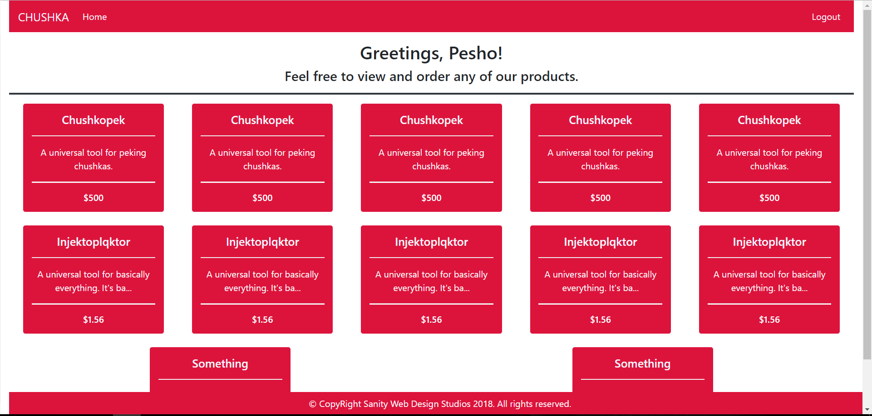

#### Product Details Template (route=”/products/details?id={id}) (logged in user)

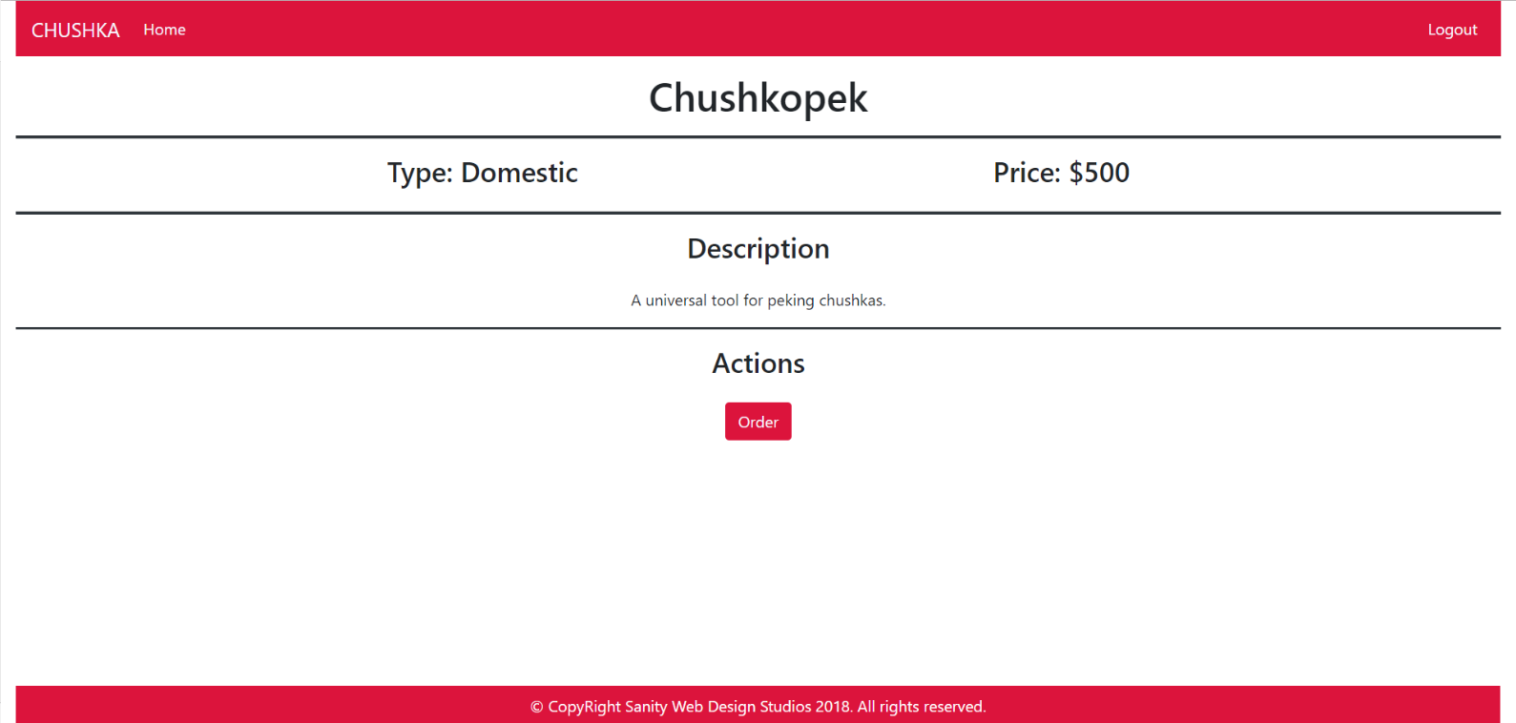

### Admin Templates

These are the **templates** and **functionalities**, accessible by Admins (**logged in** users with Role - Admin).

#### Admin Index Template (route=”/”) (logged in admin)

**NOTE**: Products on this page have their description substringed to the 50th symbol, and then accompanied by 3 dots “…”

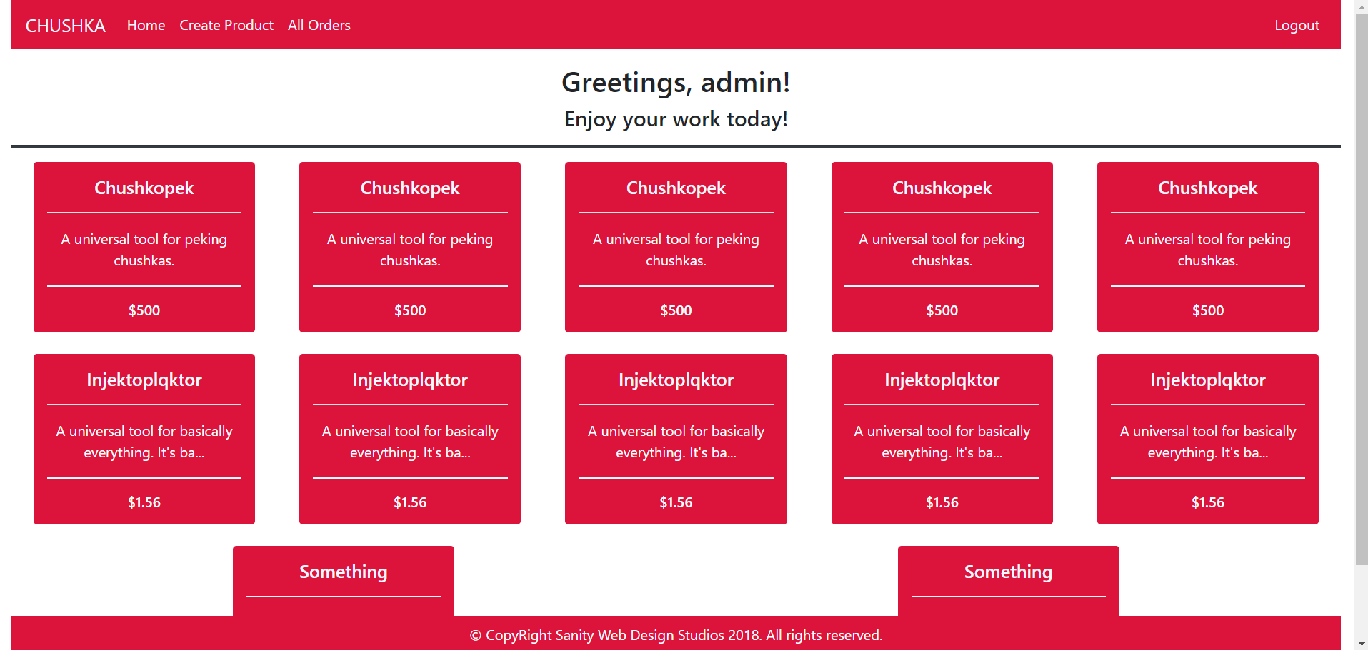

#### Prod. Details Admin Temp. (route=”/products/details?id={id}”) (logged in admin)

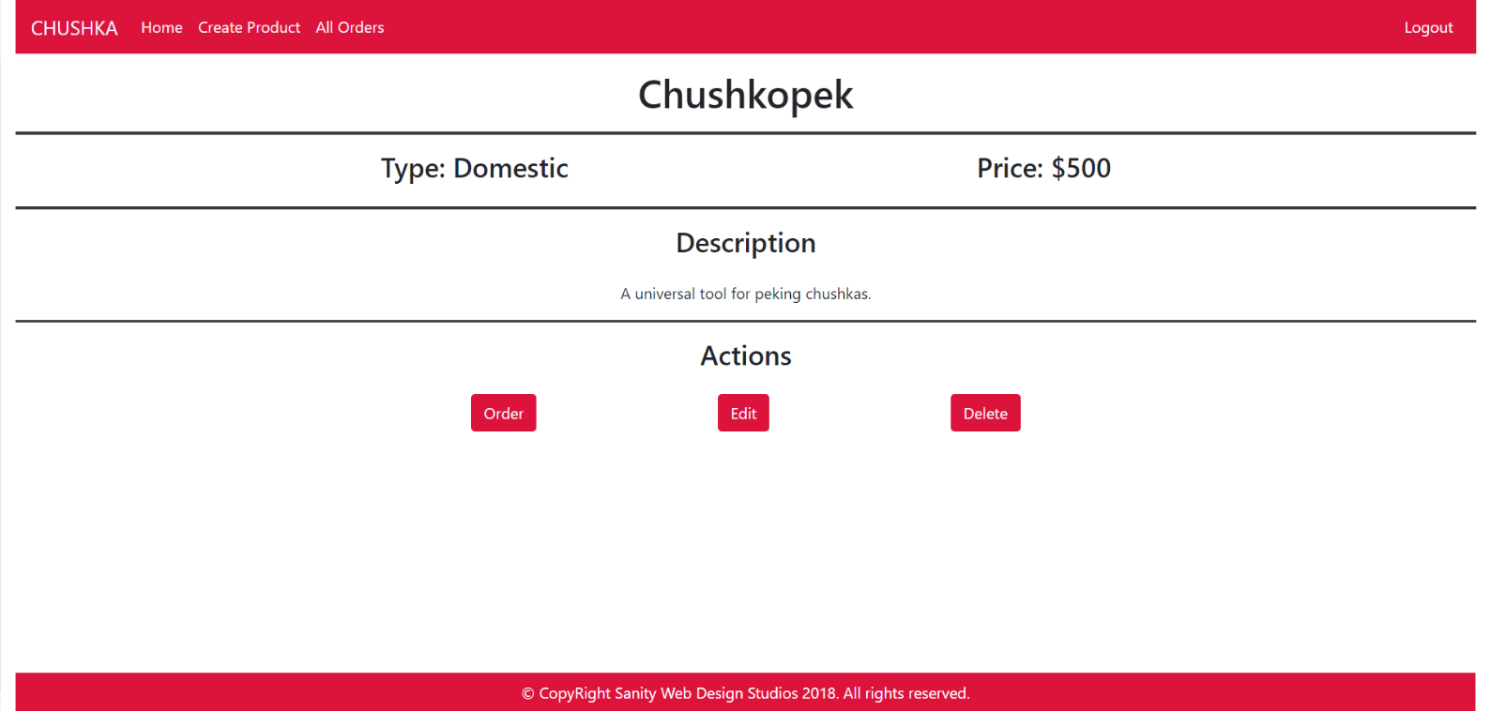

#### Product Create Template (route=”/products/create”) (logged in admin)

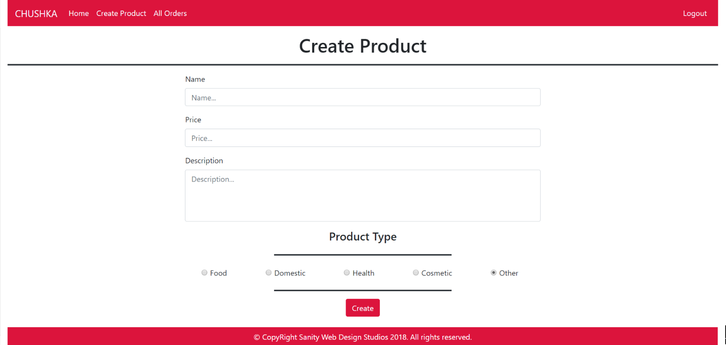

#### Product Edit Template (route=”/products/edit?id={id}”) (logged in admin)

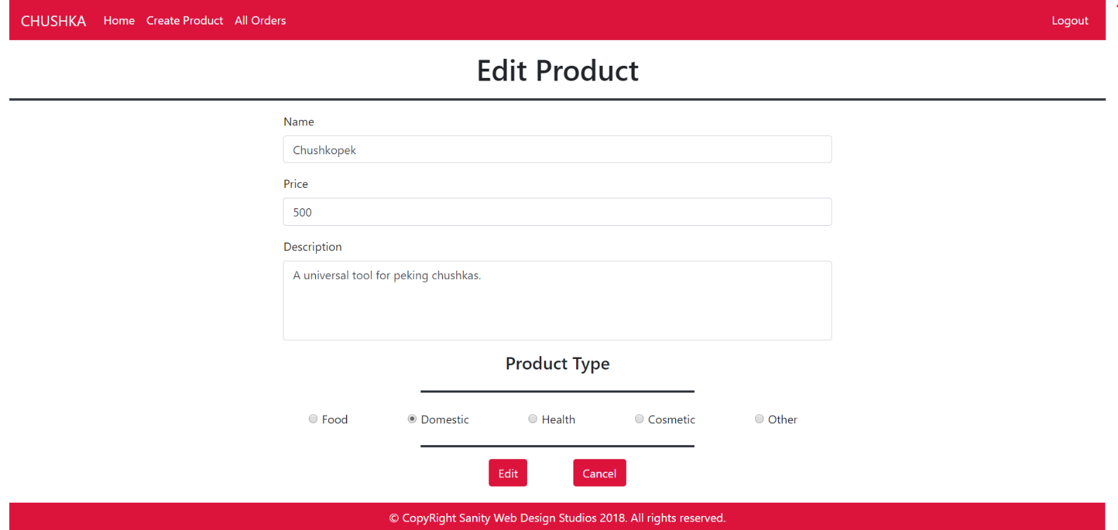

#### Product Delete Template (route=”/products/delete?id={id}”) (logged in admin)

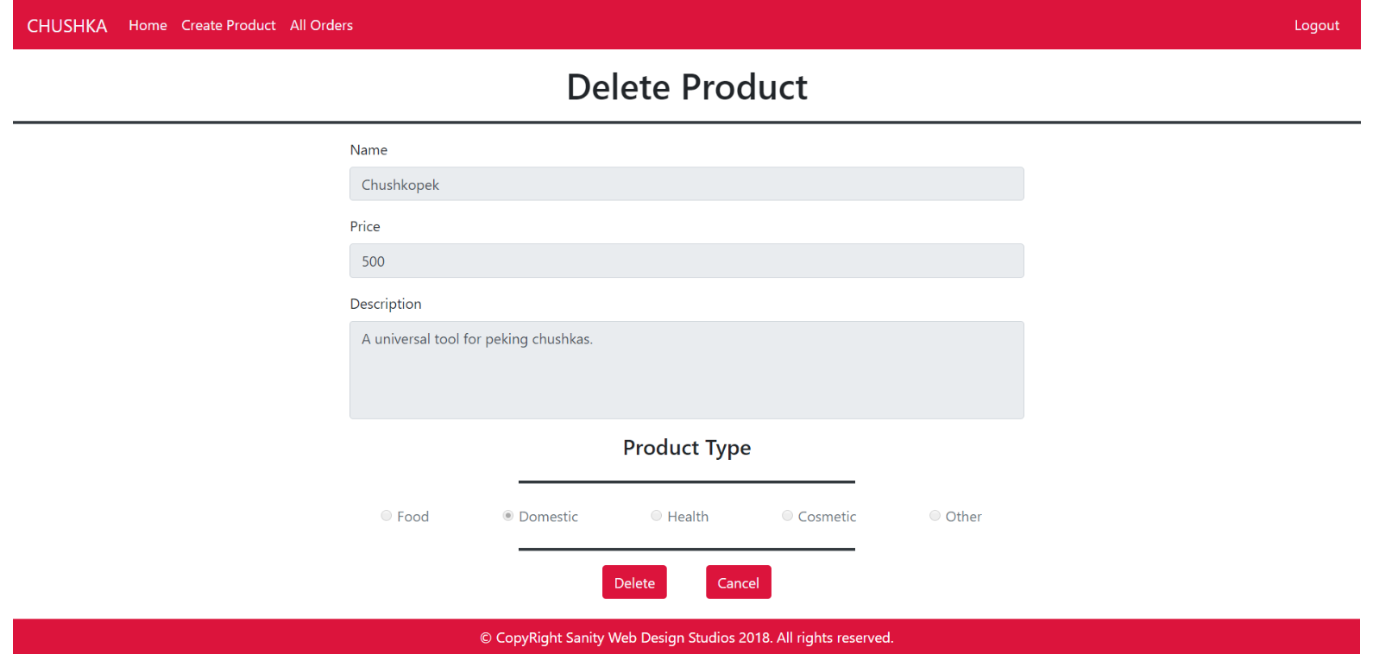

#### All Orders Template (route=”/orders/all”) (logged in admin)

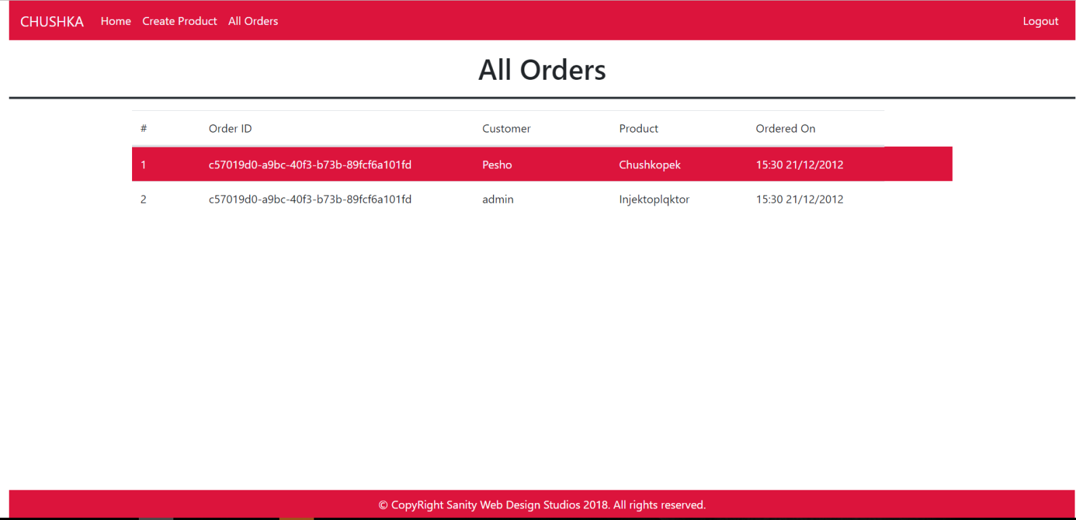

Some of the templates have been given to you in the application skeleton, but the others will be for you to implement, so make sure you implement them correctly. You can use the given ones as helpers.

**NOTE**: The templates should look **EXACTLY** as shown above.

**NOTE**: The templates do **NOT** **require** **additional** **CSS**. Only **bootstrap** and the **given css** are enough.

## Functional Requirements

The Functionality Requirements describe the functionality that the **Application** must support.

The **application** should provide Guest (not logged in) users with the functionality to login, register and **view** the Index page.

The **application** should provide Users (logged in) with the functionality to logout, and view all products, and **order** a Product (clicking on the [Order] button on the Product Details page).

The **application** should provide Admins (logged in) with the functionality to logout, and view all products, **order** a Product, **create** a Product, **edit** a Product, **delete** a Product, and **view** all Orders.

#### Users

When you register a new User, it should be assigned with a **role** – User.

**NOTE**: To test your **Admin** **functionality**, make one user an **Admin** through the database, or make the **first registered** user – an **Admin**.

#### Products

Upon clicking on the **rectangular object** holding the data about a certain Product on the User Index and Admin Index pages, you should be redirected to its Details page.

Upon **ordering** a Product, an Order should be **created** and **persisted**.

The **application** should **store** its **data** into a MSSQL database, using Entity Framework Core.

## Security Requirements

The Security Requirements are mainly access requirements. Configurations about which users can access specific functionalities and pages.

* Guest (not logged in) users can access Index page and functionality.
* Guest (not logged in) users can access Login page and functionality.
* Guest (not logged in) users can access Register page and functionality.
* Users (logged in) can access User LoggedIn Index page and functionality.
* Users (logged in) can access User Product Details page and functionality.
* Users (logged in) can access the Order Product functionality.
* Users (logged in) can access Logout functionality.
* Admins (logged in) can access **every functionality** a **normal** logged in User can.
* Admins (logged in) can access Admin LoggedIn Index page and functionality.
* Admins (logged in) can access the Admin Product Details page and functionality.
* Admins (logged in) can access the Product Create page and functionality.
* Admins (logged in) can access the Product Edit page and functionality.
* Admins (logged in) can access the Product Delete page and functionality.
* Admins (logged in) can access the All Orders page and functionality.

## Scoring

This section describes how the scoring of the Exam Preparation will be made.

### Database Requirements – 15 points.

### Template Requirements – 25 points.

### Functional Requirements – 50 points.

### Security Requirements – 10 points.